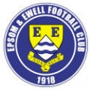 | Epsom & Ewell F.C.  6  v  Mole Valley SCR  Tuesday, 7th October 2014
For our League match this evening we welcome the players, officials and supporters of our friends from Mole Valley SCR, along with today's match officials and of course our own regular supporters.

Today’s opponents have had a great start to the season and sit alongside us currently, just inside the top half of the table.

For our part, we have had a Saturday off and you will all be aware by now of our F.A. Vase First Round draw which was completed at Wembley Stadium yesterday. As a club, you often hope for a home draw, but as a supporter, you can’t beat a trip to somewhere different, and personally, I hope we’ve pulled out someone we’ve never played before out in the countryside, much like our F.A. Cup draw that sent us to Hassocks.

We were here last Tuesday when Guildford City were the visitors and despite conceding an early goal we were well on top from start to finish and the 4-1 win was the least we deserved. Mark Jarman was most unfortunate not to score as the keeper seemed to save his best form for him, producing two great saves. However it was nice to see Kyle Hough back amongst the goals and it should also be noted that Sam Robinson scored one and had the assists for the other three!

For what it’s worth I thought Guildford City were a shadow of the side that won this League twice in successive years not so long ago and they need some serious changes to their personnel or a second relegation is not beyond them.

But enough about them, we now face a number of home games with Bedfont Sports up next on Saturday, Knaphill on Tuesday and Ashford Town (Mx) the following Saturday. The Knaphill tie is in the League Cup and it would be nice to have a run in both that and the Vase. You never know!

Please note that the club is now looking for sponsors. In particular, we are in need of match and match ball sponsors. Please take a look at the relevant section programme and please help your club; even if a couple of you pool together it all helps us and we are very grateful.

Please keep following the Salts. Glyn, the boys and the club value your support.

Enjoy the game!

Rich (Richard.c.lambert@gmail.com) on Twitter @EEFCOfficial

Cover photo this week by Gemma Jarman

George Murphy puts us ahead against Guildford City on Tuesday
with a superb header right into the top corner

Cherry Red Records
Combined Counties League
Premier Division Table 2014/15
inc 4th October 2014 | P | W | D | L | F | A | Pts | GD | H | A
Cove | 12 | 11 | 1 | 0 | 30 | 13 | 34 | +17 | 7/3 | 15/11
Ashford Town (Mx) | 11 | 10 | 0 | 1 | 31 | 6 | 30 | +25 | 18/10 | 10/1
Molesey | 10 | 8 | 0 | 2 | 37 | 11 | 24 | +26 | 22/11 | 28/2
Camberley Town | 11 | 7 | 1 | 3 | 25 | 9 | 22 | +16 | 7/2 | 25/10
Spelthorne Sports | 10 | 7 | 1 | 2 | 19 | 12 | 22 | +7 | 11/11 | 3-0
Windsor | 10 | 6 | 2 | 2 | 24 | 10 | 20 | +14 | 3/1 | 11/4
Colliers Wood United | 12 | 6 | 1 | 5 | 22 | 20 | 19 | +2 | 4/4 | 2-3
Epsom & Ewell | 11 | 5 | 2 | 4 | 23 | 16 | 17 | +7 | X | X
Mole Valley SCR | 11 | 4 | 4 | 3 | 24 | 22 | 16 | +2 | 7/10 | 18/11
Hartley Wintney | 8 | 4 | 1 | 3 | 9 | 9 | 13 | 0 | 21/2 | 1-2
Frimley Green | 11 | 3 | 4 | 4 | 20 | 23 | 13 | -3 | 0-0 | 25/4
Bedfont Sports | 10 | 4 | 1 | 5 | 14 | 20 | 13 | -6 | 11/10 | 20/12
Raynes Park Vale | 9 | 3 | 3 | 3 | 12 | 13 | 12 | -1 | 0-1 | 27/12
Horley Town | 11 | 3 | 3 | 5 | 22 | 25 | 12 | -3 | 2-2 | 6/4
Westfield | 12 | 3 | 3 | 6 | 14 | 20 | 12 | -6 | 31/1 | 0-4
Chertsey Town | 12 | 4 | 0 | 8 | 18 | 30 | 12 | -12 | 28/10 | 14/3
Knaphill | 11 | 2 | 3 | 6 | 10 | 29 | 9 | -19 | 18/4 | 4-1
Farnham Town | 13 | 1 | 4 | 8 | 15 | 29 | 7 | -14 | 17/1 | 2-0
Guildford City | 12 | 2 | 1 | 9 | 17 | 38 | 7 | -21 | 4-1 | 29/11
Badshot Lea | 12 | 1 | 3 | 8 | 13 | 30 | 6 | -17 | 21/3 | 13/12
Hanworth Villa | 11 | 1 | 2 | 8 | 13 | 27 | 5 | -14 | 6/12 | 5-2

Lucky Day? – 7th October
Played 10 - Won 8 Drawn 0 Lost 2 - F 38 A 19 - PPG 2.40 - Fantastic
Club record against Mole Valley SCR
Played 6 - Won 4 Drawn 1 Lost 1 - F 16 A 8 - PPG 2.17 - Very Good
Last visit
Saturday 30th November 2013 - Won 4-0 - Combined Counties League

Glyn Mandeville
Good evening and welcome to everyone connected with Mole Valley SCR.

We headed to Spelthorne as underdogs but came away with a great result; the lads worked so hard and got what they deserved.

We had a game plan and it worked, we defended well as a unit and worked so hard getting in behind them up front and with some great play in midfield, we took the lead with a Kyle Hough pen.

There was no looking back, they had a few chances but with big Mike in great form it was going to be our day. Dale Marvell on his 300th game for the club got a second from a corner and with them trying to get back into the game Matt Farrell broke from the half way line and passed the under the oncoming keeper for 3-0. A great result and a great day, and with players coming back from holiday and injuries it's a sign of things to come.

We then took on Guildford but the lads started badly, everything was 100 mph, passing was poor and there was a real lack of quality. We went 1-0 down after some poor defending, but a great finish from the lad. Not a good start, but that seemed to give us the kick up the backside we needed. Passing got better and the work rate we needed came to the max.

We made it 1-1 with a good goal from our man up front Kyle Hough and we then took the lead from a George Murphy header from a corner and had our mojo back. In the second half we came out and worked hard getting in behind them and had good movement, a 3rd goal came from Kyle again a great shot from the edge of the box gave the keeper who was in good form no chance; if it wasn't for him we could have had more.

They looked out of it by now and with a fourth coming from Sam Robinson it was goodnight Guildford, the lads played well apart from the first 15-20 minutes but well deserved the victory, with good attacking play and great defending. 3 points, get in there!

Cheers

Manders

Results and Fixtures
Combined Counties League Cup Second Round – Tuesday 30th September
Ashford Town (Mx) | 5-0 | CB Hounslow United
Combined Counties League – Tuesday 30th September
Epsom & Ewell | 4-1 | Guildford City
Hanworth Villa | 2-2 | Raynes Park Vale
Westfield | 4-1 | Badshot Lea
Combined Counties League Cup First Round – Wednesday 1st October
Chertsey Town | 4-2 | Hartley Wintney
Combined Counties League Cup Second Round – Wednesday 1st October
Colliers Wood United | 3-0 | Bedfont & Feltham
F.A. Vase Second Qualifying Round – Saturday 4th October
Colliers Wood United | 2-0 | Shoreham
Cray Valley (PM) | 0-2 | Horley Town
Farnham Town | 2-1 | Milton United
Flackwell Heath | 5-0 | Frimley Green
Highworth Town | 2-1+ | Hartley Wintney
Molesey | 1-2 | Greenwich Borough
Raynes Park Vale | 2-1 | Epsom Athletic
Rothwell Corinthians | 0-1 | Bedfont Sports
Spelthorne Sports | 2-1 | Risborough Rangers
Windsor | 4-0 | Binfield
Woodley Town | 0-2 | Knaphill
Combined Counties League – Saturday 4th October
Ashford Town (Mx) | 3-1 | Chertsey Town
Cove | 3-1 | Guildford City
Westfield | 2-2 | Mole Valley SCR
Combined Counties League – Tuesday 7th October
Bedfont Sports | V | Knaphill
Camberley Town | V | Horley Town
Epsom & Ewell | V | Mole Valley SCR
Combined Counties League – Wednesday 8th October
Guildford City | V | Raynes Park Vale
Combined Counties League Cup Second Round – Saturday 11th October
Sheerwater | V | Mole Valley SCR
Combined Counties League – Saturday 11th October
Chertsey Town | V | Camberley Town
Cove | V | Colliers Wood United
Epsom & Ewell | V | Bedfont Sports
Farnham Town | V | Westfield
Guildford City | V | Frimley Green
Hanworth Villa | V | Badshot Lea
Horley Town | V | Hartley Wintney
Knaphill | V | Windsor
Molesey | V | Raynes Park Vale
Spelthorne Sports | V | Ashford Town (Mx)

First Eleven Appearances - (max 14 inc Guildford City)
Name | Debut | 2014/15 |  |  |  | Career Totals
 |  | App | Sub | Total | Goals | App | Sub | Total | Goals
BROWN Oshane* | 30/08/2014 | 2 | 0 | 2 | 0 | 2 | 0 | 2 | 0
CURRIE Sam | 04/08/2012 | 2 | 0 | 2 | 0 | 96 | 5 | 101 | 2
DEAN Dan | 02/08/2014 | 12 | 0 | 12 | 0 | 12 | 0 | 12 | 0
DEWAR Ali | 29/10/2011 | 4 | 1 | 5 | 3 | 54 | 30 | 84 | 10
DOUGLIN Karl* | 03/08/2013 | 1 | 0 | 1 | 1 | 41 | 3 | 44 | 14
DOWNS Carl* | 17/09/2011 | 4 | 1 | 5 | 0 | 94 | 13 | 107 | 2
EACOTT Michael | 02/08/2014 | 12 | 0 | 12 | 0 | 12 | 0 | 12 | 0
FARRELL Matt | 02/08/2014 | 13 | 1 | 14 | 2 | 13 | 1 | 14 | 2
FERDINANDO Matthew | 20/09/2014 | 2 | 2 | 4 | 0 | 2 | 2 | 4 | 0
GAFFNEY Luke | 16/08/2014 | 5 | 1 | 6 | 0 | 5 | 1 | 6 | 0
HARPER Tommy | 15/04/2014 | 1 | 0 | 1 | 0 | 2 | 1 | 3 | 0
HAYWARD Ben | 07/03/2007 | 5 | 0 | 5 | 0 | 241 | 28 | 269 | 18
HOADLEY Harry | 15/04/2014 | 6 | 1 | 7 | 0 | 7 | 1 | 8 | 0
HOUGH Kyle | 14/08/2007 | 12 | 0 | 12 | 3 | 266 | 12 | 278 | 140
JARMAN Mark | 08/08/2009 | 2 | 4 | 6 | 0 | 133 | 50 | 183 | 76
MARVELL Dale | 15/01/2000 | 8 | 3 | 11 | 5 | 258 | 43 | 301 | 85
MURPHY George | 28/03/2013 | 9 | 1 | 10 | 1 | 50 | 5 | 55 | 3
MUTIMA Lionel | 05/08/2014 | 4 | 2 | 6 | 0 | 4 | 2 | 6 | 0
NELMES Elliott* | 05/08/2014 | 2 | 0 | 2 | 0 | 2 | 0 | 2 | 0
PANAYI Anthony | 14/11/2010 | 8 | 1 | 9 | 0 | 135 | 15 | 150 | 4
ROBINSON Sam | 22/10/2011 | 9 | 1 | 10 | 4 | 33 | 4 | 37 | 9
SHAW Ollie | 20/09/2014 | 0 | 4 | 4 | 0 | 0 | 4 | 4 | 0
SMITH Taylor | 02/08/2014 | 11 | 0 | 11 | 5 | 11 | 0 | 11 | 5
TANTON Matt | 02/08/2014 | 8 | 2 | 10 | 1 | 8 | 2 | 10 | 1
TAYLOR James | 26/08/2013 | 9 | 1 | 10 | 1 | 26 | 7 | 33 | 2
VAN GELDER Julian | 12/09/2006 | 0 | 1 | 1 | 0 | 0 | 2 | 2 | 0
WHITE Sean | 02/08/2014 | 3 | 6 | 9 | 2 | 3 | 6 | 9 | 2
* Player has left the club

From behind the goal
Epsom & Ewell 4-1 Guildford City – Combined Counties League
Tuesday 30th September 2014

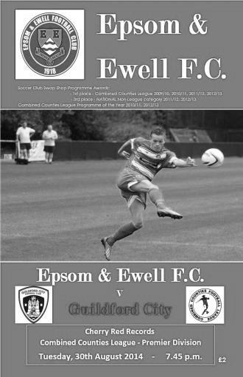
Dominant performance earns first home win of season

The Salts registered their third three goal win in four matches as they recovered from the shock of conceding a goal early to dominate almost the whole contest against a very disjointed and by the end, dispirited Guildford City.

Taylor Smith was unavailable through injury, being replaced by Mark Jarman, while Matt Tanton came in for Matt Ferdinando, but the rest of the team was unchanged following our fine win at Spelthorne Sports on Saturday, as you might expect. What most supporters wouldn't have expected was to go behind so early in the game, as with just a minute and 27 seconds on the clock, Navid Zandi clipped the ball over Michael Eacott, after his own clearance had gone straight to a Guildford player, who then fed it back to the scorer with a clever pass.

However, this appeared to make no difference to our mind-set as we tore into the visitors from that point onwards. Kyle Hough gave an indication of the influence he would have when he beat an offside trap on the left and cut in towards goal, choosing to shoot low, but the keeper Antony Hall made the first of a few good saves, this one with his feet to clear the danger.

Dale Marvell was then set up by Hough and his low shot from the other flank was saved and Sam Robinson was just wide with a shot after some good interplay between him and Hough. After 22 minutes a last ditch tackle prevented Jarman getting a tap in following a good Matt Tanton left wing cross before our centre forward earned a corner from his cross that caused panic in Guildford territory.

The goal was coming and I think everyone in the ground knew it. We weren't expecting two to arrive so quickly though! In the 32nd minute Robinson struck at goal with the ball taking a little deflection. This was enough to cause Hall to spill the ball and Hough was there for a classic poacher’s goal. Within a minute we were ahead as Robinson's corner was headed into the top corner by Captain, George Murphy. The attacks continued and Jarman had a powerful shot deflected into the side netting before another last moment challenge denied James Taylor what was almost a tap in but his attempt was blocked away.

The visitors were rattled and looked a shadow of the side that had won this League in 2012. There were arguments between players, the like of which I'd never witnessed before and it was just a matter of time before we would score again. After 43 minutes Tanton missed a

great chance when he arrived at the far post for Jarman's deep cross but from no more than two yards wide he couldn't make a proper contact and the ball went wide. Moments later a great Taylor header from a Matt Farrell cross cannoned back off the post and away. It would have made a great 21st birthday present!

There was a small concern when Dan Dean made a really good saving challenge on Guildford's only other real attack of the half. However, he did bring the player down as he followed through, so for a moment you feared the worst, but the referee was perfectly happy with the tackle, much to Guildford's annoyance and we went in at the half leading 2-1.

Despite our dominance, it was felt at half time that missed chances may come back to haunt us but I also believed that they would have performed a small miracle if they were able to organise their defence well enough to stop us scoring again. Despite an improvement to open the half, a poor back pass was intercepted by Jarman in the 55th minute, who nicked the ball just ahead of the keeper, but unfortunately for him the ball was so far wide by the time he caught up with it that he could do little, although his attempt from a narrow angle still required a block by a defender.

Jarman had another shot blocked following a good cross by Tanton before the latter was set off down the left wing, before cutting in and shooting at the keeper. Dean was next to show as a Robinson delivery was met by a looping header at the far post that just dropped onto the roof of the net.

The visitors were becoming more and more frustrated with the referee and this resulted in a couple of bookings for dissent. Then the centre of their defence opened up and Robinson put Jarman through, his shot requiring a top class save from Hall to flick the ball over the bar. Within sixty seconds though we had our third goal, as in the 66th minute Robinson was confronted by two defenders out on the touchline but threaded the ball to Hough who turned and shot low, giving the keeper no chance. The ball grazed a defender but I can confirm that it made no difference to its trajectory.

Marvell headed another attempt just wide of the far post as we continued to pile the pressure on. Jarman was yet again unlucky to see his well struck shot heading for the top corner until Hall got a hand to it but our fourth goal arrived in the 86th minute when a loose ball went across goal to Robinson who smashed the ball in with the keeper unsighted by a defender. Robinson could have made it five right at the end when Hough's pass found him with just the keeper to beat but appeared to lose his bearings and shot just wide of the post.

In summary this was a super performance. We brushed off the early goal and worked hard all evening, fully deserving the three points. Guildford were particularly poor and will face a relegation battle that would have seemed unthinkable a few months ago if they don't improve rapidly, but that shouldn't detract from our boys play as in four days we have defeated two of the pre-season favourites by three clear goals and are now up to eighth in the table.

Team: Michael Eacott, James Taylor, Luke Gaffney, George Murphy, Dan Dean,
Matt Tanton, Sam Robinson, Matt Farrell, Mark Jarman, Kyle Hough, Dale Marvell

Subs: Matthew Ferdinando for Tanton (76), Ollie Shaw for Jarman (83),
Anthony Panayi for Taylor (88)

Club Records - 7th October
Date | Day | Competition |  | Opponents |  | Scorers
07/10/33 | Sat | Amateur Cup 1q | H | Redhill | 4-1 | L.Marlow (3), F.Copsey
07/10/50 | Sat | Amateur Cup 1q | H | Cobham | 7-2 | S.Faggetter (4), P.Jordan (2), T.Wright
07/10/61 | Sat | Corinthian League | A | Dorking | 6-4 | J.Punter (4), B.Robinson, G.Roberts
07/10/67 | Sat | Amateur Cup 1q | H | BAC Weybridge | 4-2 | C.Kelly (2), A.Parrott, T.Stafford
07/10/72 | Sat | Athenian League 2 | A | Rainham Town | 1-5 | M.Talmage (pen)
07/10/78 | Sat | Isthmian League 1 | H | Walton & Hersham | 2-0 | T.Tuite, R.Breen
07/10/89 | Sat | Isthmian League 2s | A | Horsham | 3-0 | A.Van Sliedregt, P.Andrews, o.g.
07/10/95 | Sat | Isthmian League 3 | H | Wingate & Finchley | 7-1 | A.Boxall (2), K.Webb (2), S.Smith, T.Smith, A.Rawlinson
07/10/00 | Sat | Isthmian League 3 | A | Arlesey Town | 1-2 | M.Freeborough
07/10/08 | Tue | Combined Counties  Premier Division | H | Chessington & Hook United | 3-2 | D.Marvell, R.Burns (2)
Historical Decades
90 years ago – Epsom Town
04/10/24 | Sat | Surrey Senior League | H | Camberley & Yorktown | 4-2 | R.Marlow (2), F.Kent, S.Bristow
80 years ago – Epsom F.C.
06/10/34 | Sat | Amateur Cup 1q | H | Merton | 4-1 | E.Hannam (2), M.Wiggins, R.Marlow
70 years ago – War time Epsom Town
07/10/44 | Sat | South Eastern Combination League Cup Semi Final | H | Sutton United | 4-7 | G.Brogdale (2), S.Tingey, T.Bartlett
60 years ago – Epsom F.C.
09/10/54 | Sat | Corinthian League | H | Grays Athletic | 2-4 | T.Wright (2)
50 years ago – Epsom & Ewell
10/10/64 | Sat | Amateur Cup 1q | A | Westfield | 1-0 | B.Mackay
40 years ago – Epsom & Ewell
05/10/74 | Sat | Surrey Senior League | H | Worplesdon | 4-0 | J.Eales (2), D.Ritman, T.Lee
30 years ago – Epsom & Ewell
06/10/84 | Sat | Isthmian League  Premier Division | H | Bishop's Stortford | 0-0
20 years ago – Epsom & Ewell
08/10/94 | Sat | Isthmian League 3 | A | Northwood | 0-0
10 years ago – Epsom & Ewell
09/10/04 | Sat | Isthmian League 2 | A | Wembley | 0-1

History Corner – 7th October
90 years ago this week we played our first ever game against Camberley. Although known at the time as Camberley and Yorktown, the suffix would be dropped in 1967 to leave us with the team we know well today. The sequence got off to a winning start with a 4-2 win at the Horton Hospital Grounds with Reg Marlow scoring twice.

80 years ago today we hosted Redhill in an Amateur Cup tie at West Street. Although it was to be the F.A. Cup that would take up the club’s interest this season, it was always nice to get one over “the Lobsters” and a Leslie Marlow hat trick helped us on our way. Just under 3,000 were present this day, a figure beaten two rounds later when Sutton United ended the run 2-1 in front of 3,500!

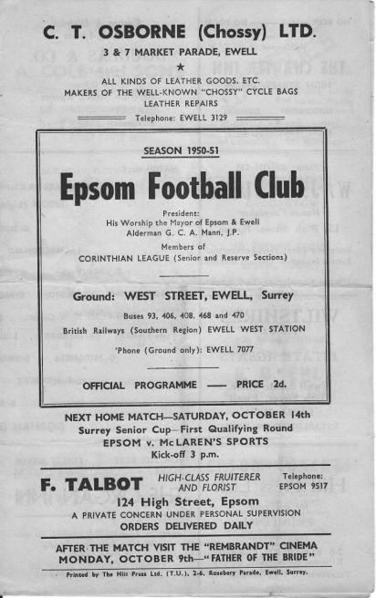
70 years ago this week our wartime Epsom Town hosted Sutton United in the League Cup Semi-Final, losing 4-7! The final score was even more frustrating when you realise that we led 4-1 at one point, and 4-2 at half time before collapsing entirely.

64 years ago today our Player / Coach Sid Faggetter, a veteran striker with many years of service already under his belt, scored four times as we defeated Cobham 7-2 in an Amateur Cup tie at West Street. (see programme right) Dagenham would eventually end our run in the final qualifying round by the only goal.

53 years ago today Jim Punter scored four times in a strange 6-4 win at Meadowbank. There was even time for keeper Brian Jobson to suffer injury and get stitched up before returning to the field of play!

47 years ago today a young striker by the name of Chris Kelly scored twice in our 4-2 home win over BAC Weybridge in the Amateur Cup. The works team would later change their name to Bae Weybridge before disappearing in the late eighties.

40 years ago this week tiny Worplesdon were no match for us as we cruised to a 4-0 win in the Surrey Senior League. Johnny Eales scored twice along with Dave Ritman and Trevor Lee in a match where we rarely got out of first gear.

19 years ago today Wingate & Finchley were humbled 7-1 at Merland Rise with all of our strikers getting in on the action. We had recently won there 4-1 so this completed a double, and we would end up scoring as many goals as Champions Horsham and runners-up Leighton Town, but would have to settle for seventh.

14 years ago today we made our one and only visit to Arlesey Town and gave a good account of ourselves against the eventual Champions, who required a late goal by a young Dave Kitson to edge us out 2-1. He did fairly well for himself in the years that followed!

Centre page for results

Centre page for results

Mole Valley SCR – History
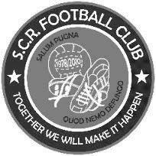
Chairman and Life President Alan Salmon founded SCR F.C in 1978, when the club began life as INRAD FC, based in Carshalton. The club entered a new era when Alan moved to Sutton and arranged sponsorship with his new neighbour, CENTRE 21 FC was born. This era saw the club running one Saturday side, three Sunday sides and three Youth sides. Centre 21's sponsorship continued until the club's youth players were no longer under 21 years old.

The club again sought a new identity; SUTTON COMMON ROAD FC was formed and subsequently abbreviated to SCR FC. Since then the club has had five major sponsors whose names have been incorporated into the clubs affiliated name: SCR PLOUGH (twice), SCR GRAPES, next the club's longest sponsor SCR LITTEN TREE (7 years) & finally SCR Kingfisher, Ewell with whom we started our venture in Saturday football in 2004/05 until the then landlord Andy Coxs' departure.

It was at this point that the club took the decision to revert back to using the SCR name alone, feeling that as they strove for continued promotion they needed to disassociate ourselves with the pub team image. That said the club did take sponsorship form the Fox & Hounds public house in Carshalton for the Sat first team in 2006/07, but the decision was made that the pub name would not be incorporated into the affiliated name, for the above reason.

The start of the 2007/08 season saw the club running three Saturday sides, with Darren Salmon in charge of the 1st team (newly moved to the Middlesex County League) after an unsuccessful attempt at promotion from the Surrey South East Combination (finished 3rd on goal difference by 1 goal). This also saw a name change to Sutton Common Rovers.

During this shake up several additional changes took place in 2007/08 season, Alex moved in a new temporary role as 1st team assistant, alongside Darren. The youngest Salmon, Justin, alongside Dave Newbury took over the running of the Sunday first team, with Stephen Snowdon and Alan Reed in charge of the Sunday Reserves.

A third place finish in the Middlesex County League Premier Division in 2007/08 meant that the clubs promotion to the CCL was not assured but months of hard work & determination from the management team eventually secured a place within the league constitution for the clubs first time in their 30 year history at the league AGM in June 2008.

The club also took the decision to take their reserve team into the CCL. Taking a place within the leagues Reserve Division under the joint guidance of Justin Salmon & Alex Avis.

2008 also saw the latest name change of the club, this time with the inclusion of 'Mole Valley' to form the new name Mole Valley SCR F.C. reflecting the area in which they played. In 2009 the club was forced to yet another move from its shared ground in Mole Valley to its continuing tenancy at Cobham FC. This season also saw a temporary end to the SCR Sunday side, although the Vets which had been formed the previous season was able to welcome an influx of players

The 2009/10 season saw the club win the Combined Counties League Division 1 and earn promotion to the Premier Division for the first time in the clubs history. The season also saw the side make its FA Vase debut, when winning 2-1 at Guildford City (although the side lost 1-0 at home to Beckenham Town the next round). The club also featured in its first ever county cup final, narrowly losing the Surrey Premier Cup Final to Sutton Utd Reserves 5-3 on penalties, after the match had finished 1-1 after extra time.

2010/11 again saw the club compete in the Combined Counties Premier Division, and make their debuts in both the FA Cup (a disappointing 5-0 loss to Chertsey Town) and in the Surrey Senior Cup (a 4-1 defeat against Egham Town) and another cup loss came in the FA Vase against Banstead Athletic (3-2).

On the league front the season was a success with the side consolidating in an excellent 8th spot, in their first season in the Premier Division, and reaching the semi final of the EL Records Premier Challenge Cup - where they turned in one of their worst performance of the season en route to a 2-1 extra time defeat against Wembley.

Season 2010/11 saw the creation of the Colts section for the first time in the clubs history, with three sides at U9 x2 and U8 competing in the Surrey Youth League.

2011/12, was far and away the most disappointing season in our short Saturday Senior football history. The firsts lost the sum total of 18 players and despite a frantic rebuilt, lost the first 14 competitive games of the season before a creditable run in the dying months was not sufficient to avoid the drop back to Division One.

Season 2012/13 was initially expected to be a period of stabilisation after the disappointment of relegation, and hardly exploded into action. Defeat in the FA Cup came at the hands of fellow CCL side Badshot Lea (4-1 in a replay, after a 1-1 draw), whilst there was a win in the FA Vase, 2-0 over Sussex Division 1 side Sidley Utd – before defeat against Frimley Green in the next round. In October the signing of Phil Page boosted the side, but three successive defeats against South Kilburn, Frimley Green and Warlingham looked to have ended any promotion hopes, but a 20 game unbeaten run at the end of the season saw the side pip Westfield for runner’s up on the last day of the season.

Season 2013/14 had high hopes of consolidation, but after a bright start things fell away and at the turn of the season the side was fully in a relegation battle. The introduction of new signings Gavin Dilley, Anson Cousins, Harry Smart and Michael Burton provided fresh impetus, but the team continued to hover around the relegation zone. The final game of the season saw goals from Burton 2, Page and Cousins give the side a 4-4 draw with Horley Town, securing the point that preserved their Premier Division status.

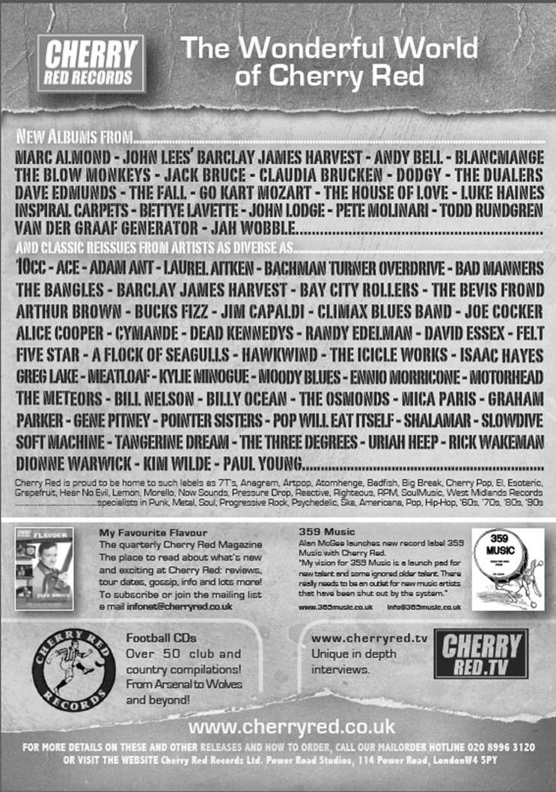

Player Sponsorship
Here is the latest list showing all of the players and Management available for sponsorship. Sponsorship costs £40 so if you want to help the club, the player and get your name in the programme for the season, just let us know.

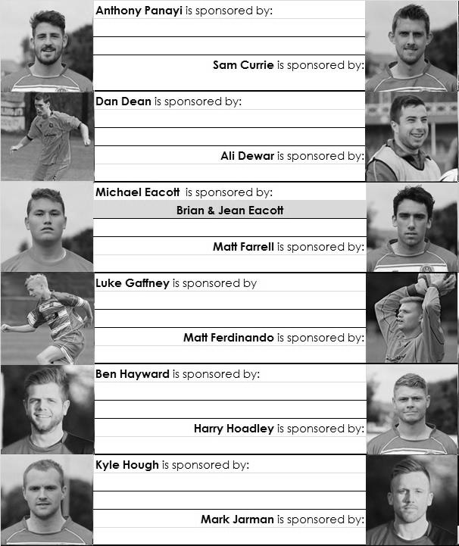

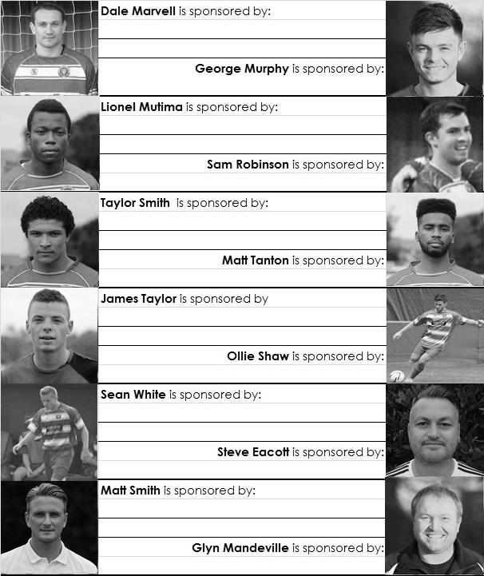

We are not fussy, we’ll take cash or a cheque! Any donation will help the club and is much appreciated.

Every Opponent A-Z
Over the years we have played many, many different opponents. Exactly how many is a difficult question, as it all depends on your definition. Are Camberley & Yorktown different to Camberley Town, or are Epsom Town different to Epsom F.C. or Epsom & Ewell F.C.?

In my analysis I have classed them as the same team, and will work through them all from A to Z. Some we have played many times, whilst others we have met maybe just once or twice. Enjoy!

Leyton: Played 9 - W1 D3 L5 - F7 A18 - PPG - 0.67 - Awful
Wingate: Played 16 - W5 D5 L6 - F27 A32 - PPG - 1.25 - Below Average
Leyton Wingate: Played 5 - W2 D0 L3 - F6 A11 - PPG - 1.20 - Below Average

This one is a little complicated. There used to be two clubs, Leyton and Wingate. When Wingate lost their ground at Hall Lane, Hendon in 1972. Three years later they elected to merge with Leyton. Despite the distance between the two areas, everything seemed fine until in 1992 Wingate de-merged and then joined forces with Finchley to become the Wingate & Finchley we know today and that I have previously covered.

Leyton were a very successful club historically, winning the Amateur Cup twice in the twenties and the London League three times. Their move up to the Athenian League left a space that Epsom Town were elected to fill in 1927.

However, we did not actually meet them until they defeated us in the final qualifying round of the Amateur Cup by four goals to one at West Street on 27th November 1965. This was a big match for us, having not reached this stage since the late fifties and we would never get this far again. Leyton however were about to have a rough patch themselves and when we had our toughest times in the late sixties and early seventies, they were right down at the bottom of the Athenian League; a club, like us, in disarray.

Despite them only recording one top half finish in four seasons, we were still only able to beat them once in eight attempts, on 31st October 1970 when Shaun Smyth, now the owner of the Print Centre that collates this programme, scored the winner. Our final meeting with them came in the 1972/73 season before we were cut adrift to the Surrey Senior League. What is often forgotten is that we were not actually bottom of the table that season. That “honour” went to Wingate.

Coincidentally, our matches against Wingate also started in the 1965/66 season and ended in 1972/73! Over those eight seasons and 16 matches Wingate just held the advantage but only just.

Of all the matches played in this sequence, the most memorable undoubtedly came on 17th December 1966. We had just been suspended for on field disciplinary matters but our Chairman at the time George Tarran, together with Manager Tony Williams managed to overturn the decision at appeal. The relief at the club was immense and this match, played the day after the appeal ended up 7-5 to Epsom!

Wingate had other issues of concern to deal with at the time. Their ground at Hall Lane was to be compulsorily purchased by the Government, or more accurately, the Department of Transport, and it now sits under the M1 Motorway extension. They decamped to Finchley’s Summers Lane ground but this didn’t last.

Which brings me to Leyton Wingate! Following the merger they remained in the Athenian League, so, as is often the case with many teams we played around this time, we met them on the way

down to the Surrey Senior League, and then after Wembley Stadium, on the way back up!

Our first meeting with the newly merged club came on 7th September 1976 as members of the Athenian League Division One, where two goals from Martin Peters and one from Tommy Tuite gave us a 3-1 win, although they returned the favour at West Street by four goals to one in May 1977. They were due to visit us earlier in the year, but our game was postponed because of a late arrival on the evening of 13th April!

At the conclusion of the season, most of the top flight Athenian clubs, including ourselves, were elected to the Isthmian League. However, Leyton Wingate were not; presumably due to concerns about ground grading at the Hare & Hounds ground in Lea Bridge Road. It was an old ground and was very hemmed in by housing. We would not see them for many years while we had a run of success all the way to the Isthmian League Premier Division.

Those ground concerns remained until the mid-eighties when the Isthmian League finally allowed them in. A promotion for them was met by relegation for us and we were back together for 1986/87 in the Isthmian League First Division. It was a bad season for us and they defeated us home and away.

We also went there on one other occasion as we also visited Leytonstone / Ilford who were also in our League but had lost the use of Granleigh Road and were groundsharing at the Hare & Hounds. Both I and Gary Vickers, another regular supporter at the time were completing a sponsored walk of 24 miles to the ground, setting off from the club at 11.30 and arriving there some seven hours later, thoroughly exhausted. Fortunately we were able to scrounge a lift home as I didn’t fancy walking back! Oh yes, and we lost 2-0!

We met them on one final occasion in November 1991 when we defeated them 1-0 in the London Challenge Cup with a goal from Graham Morris, and following the departure of Wingate in 1992 the club reverted to the name of Leyton F.C. once again. But not for long; they then merged with Walthamstow Pennant to become Leyton Pennant in 1995 but this was acrimonious and a new club formed in 1997 successfully claimed the name back. Leyton Pennant are known today as Waltham Forest and play in the Ryman League.
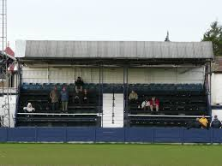
This newly formed but actually very old Leyton F.C. then played in the Essex Senior League, flying up the tables and only just failing to get promotion to the Conference South in a play off. However, this was the high water mark and in 2009 the Chairman pleaded guilty to this part in a £16m VAT fraud and was sentenced to six years in prison. This finally caught up with them in 2011 when the club had to withdraw from the Ryman League and finally the famous name is no more.
The main stand at the Hare & Hounds ground, which still exists, but not for sports

Match and Ball Sponsorships – 2014/15
Opponent | Date | Match Sponsor | Ball Sponsor
Raynes Park Vale | 05/08/14 | Club President - Stella Lamont
Horley Town | 25/08/14 | Epsom & Ewell F.C. Management Committee
Croydon (FAC) | 30/08/14 | Media Officer - Richard Lambert
Frimley Green | 13/09/14 | Dave Gaffney and friends
Guildford City | 30/09/14 | The Jarman family
Mole Valley SCR | 07/10/14 | Mark and Carmel Murphy
Bedfont Sports | 11/10/14 | Epsom & Ewell F.C. Colts
Knaphill (LC) | 14/10/14
Ashford Town (Mx) | 18/10/14
Chertsey Town | 28/10/14
F.A. Vase - 1st Round | 01/11/14 | If drawn at home
Spelthorne Sports | 11/11/14
Molesey | 22/11/14 | Provisional and dependent on Vase progress
Camberley Town (SSC) | 02/12/14 | Provisional date
Hanworth Villa | 06/12/14
Windsor | 03/01/15
Farnham Town | 17/01/15
Westfield | 31/01/15
Camberley Town | 07/02/15
Hartley Wintney | 21/02/15
Cove | 07/03/15
Badshot Lea | 21/03/15
Colliers Wood United | 04/04/15
Knaphill | 18/04/15
For League, League Cup and Surrey Senior Cup Matches:

Match sponsorship - £40.00 Match ball sponsorship - £25.00.
Combined Offer of Match and Match Ball sponsorship for £55.00.

For F.A. Cup and F.A. Vase matches:

Match sponsorship - £50.00 Match ball sponsorship - £30.00.
Combined Offer of Match and Match Ball sponsorship for £65.00.
----------------------------------------------------------------------------------------------------------------------------
Sponsorship includes

Admission, programmes, advertising (if required) and hospitality.

If you are interested, just speak to a Committee Member, you know where we are!
Alternatively, drop me an email at: richard.c.lambert@gmail.com

Photos of the Week
This week’s photos from Gemma Jarman show who else but Dale Marvell. To commemorate his 300th match for the club at Spelthorne, he scored his 85th goal for us! Dale doesn’t score many headers, but this one, our second goal of the game, broke the Spelthorne Sports resistance, even though he is not in the actual picture! His celebrations are captured below.

As an aside, behind the goal celebrating is Nick Gibbs, a former regular supporter who used to run the Club shop in the early eighties and was the person that got me interested in collecting programmes and ground hopping. Cheers mate, you’ve cost me thousands of pounds!!

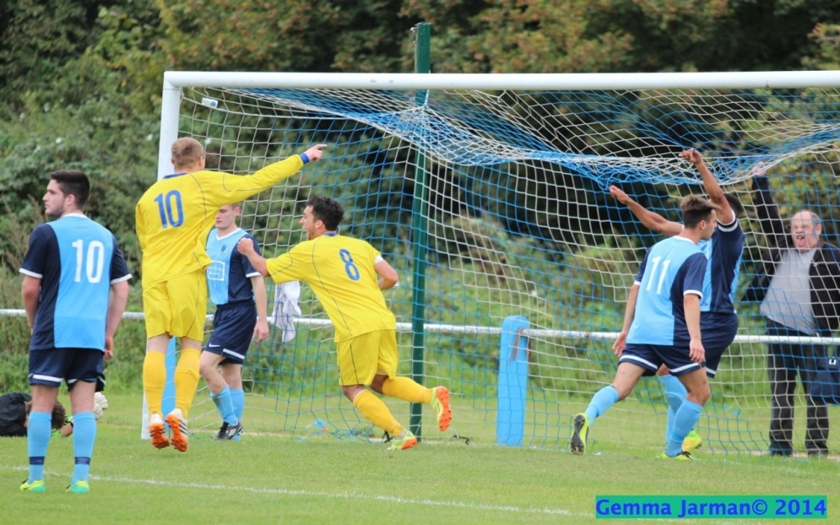

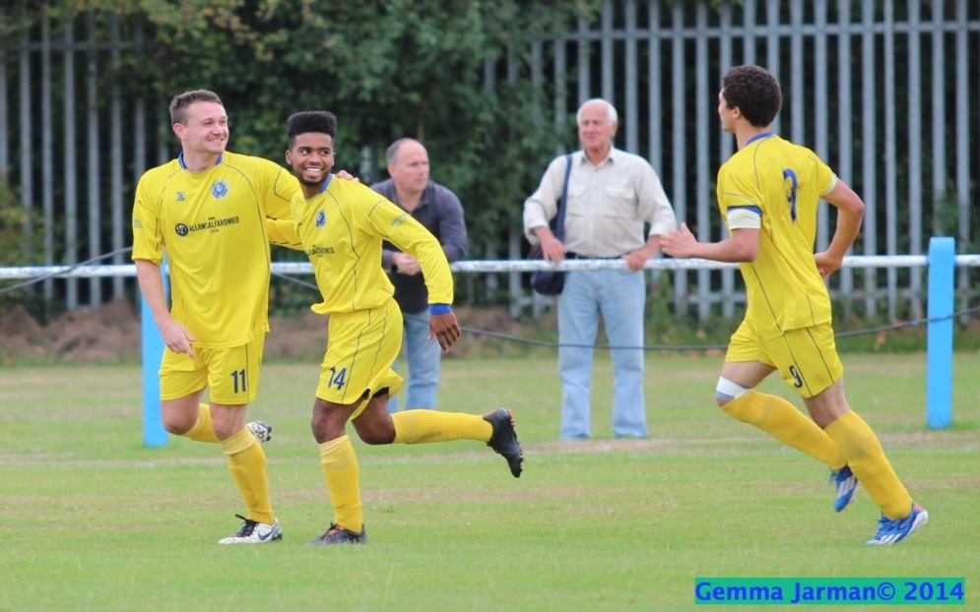
Many more of Gemma’s photos from almost every Salts game played in the last five years are available on our website: Why not have a look?

Combined Counties League – Premier Division
Tuesday, 7th October 2014 - Kick-off 7.45 p.m.
Epsom and Ewell  (Royal Blue & White hoops) | V |  | Mole Valley SCR  (All Red)
 | NUMBERS
Michael Eacott |  |  | Gavin Dilley
James Taylor |  |  | Rob McCarry
Luke Gaffney |  |  | Adam Fletcher
© George Murphy |  |  | Liam Holden
Dan Dean |  |  | Nathan Davey
Matt Tanton |  |  | Nehemiah Adams
Sam Robinson |  |  | Arnold Okiror
Matt Farrell |  |  | Jordan Knight
Taylor Smith |  |  | Harry Smart
Kyle Hough |  |  | Richard Monan
Dale Marvell |  |  | Andrew White
Mark Jarman |  |  | Chris Hugill
Lionel Mutima |  |  | Fabian O’Brien
Matthew Ferdinando |  |  | Reece Jackson
Ollie Shaw |  |  | Luke Harmsworth
Anthony Panayi |  |  | Dan Wilson
Ben Hayward |  |  | Richie Smith
Ali Dewar |  |  | Nathan Oliver
Harry Hoadley |  |  | Danny Fernandez
Glyn Mandeville | MANAGER |  | Darren Salmon
Matt Smith | ASSISTANT / HEAD COACH |  | Luke Tuffs / John Earl
Steve Eacott | GOALKEEPING COACH |  | Jordan Bradley
REFEREE: M.Edwards (Sutton)
ASSISTANTS: P.Maskell (Epsom), R.Van Niekerk (Sutton)
Today’s Match and Match Ball are sponsored by
Mark and Carmel Murphy, who are regular supporters and also the parents of our defender, George.

OUR NEXT VISITORS TO HIGH ROAD
Bedfont Sports
Saturday 11th October 2014 - Kick-off 3.00 p.m.
Combined Counties League – Premier Division

